**Paxos Implementation**

**1. Summary**

This report details the implementation of a distributed consensus system using the Paxos protocol. The system enables multiple nodes to achieve agreement on proposed values, ensuring consistency.

**2. System Architecture**

**2.1 Core Components**

The system is built around four primary components:

1. Network Layer
   1. TCP-based communication infrastructure
   2. Connection pooling for both ingress and egress
   3. Dynamic connection management
   4. Message serialization
2. Peer Management
   1. Role-based peer organization (Proposer, Acceptor, Learner)
   2. Dynamic peer discovery
   3. Quorum size calculation
   4. State synchronization
3. Consensus Engine
   1. Paxos protocol implementation
   2. Prepare/Accept mechanism
   3. Value selection logic
   4. Round management
4. State Management
   1. Thread-safe data structures
   2. Persistent state tracking
   3. Concurrent access control

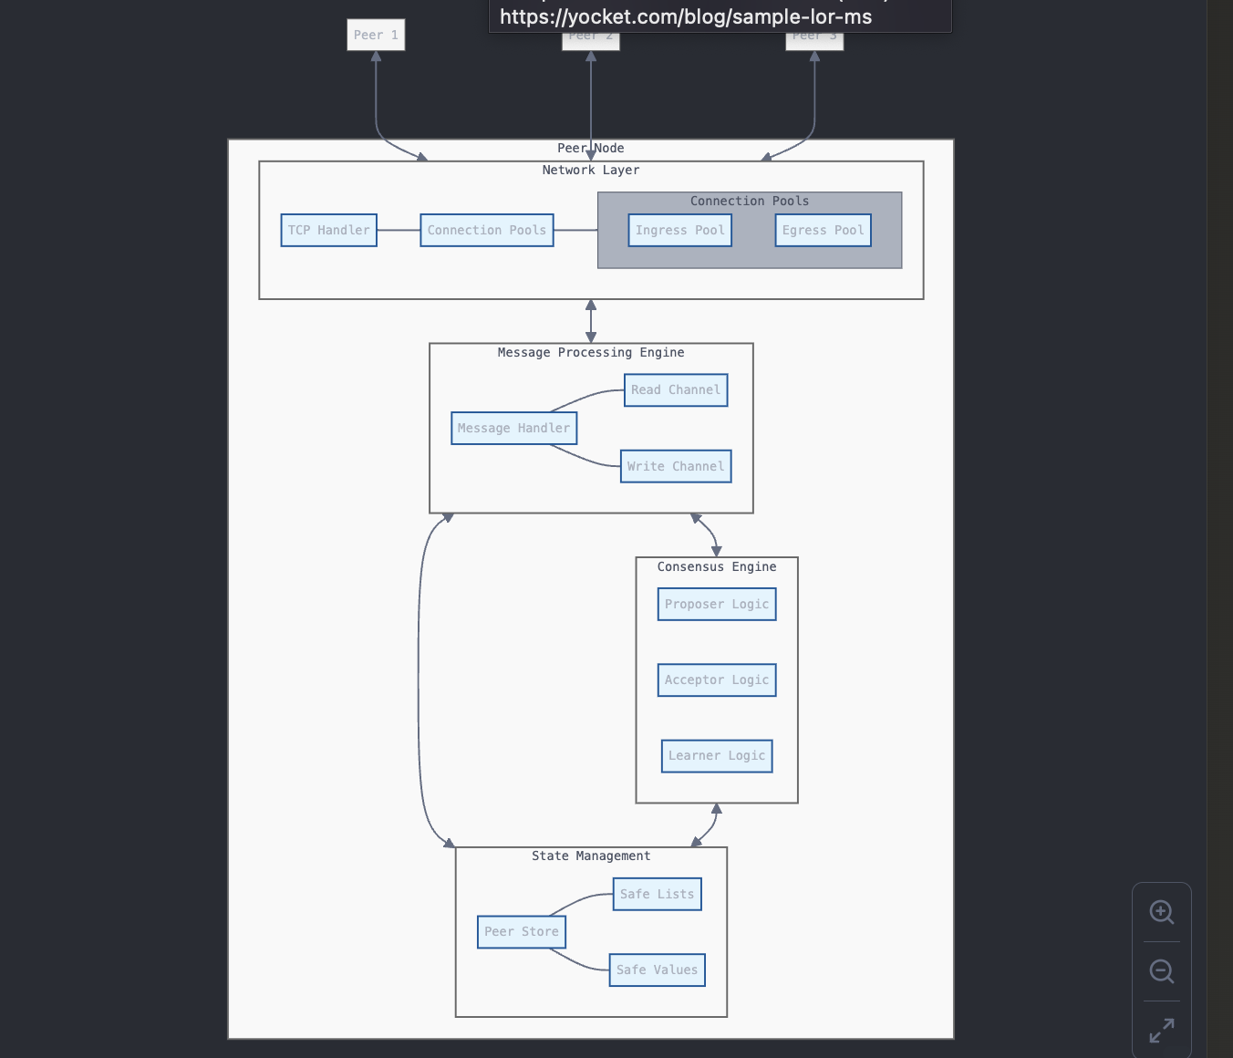**2.2 Message Flow Architecture**

The system implements a message-passing architecture with:

1. Asynchronous message processing
2. Dedicated channels for read/write operations
3. Structured message types
4. Round-based message ordering

**3. Protocol Implementation**

**3.1 Paxos Protocol States**

The implementation follows the standard Paxos protocol with the following states:

1. Idle
   1. Initial state
   2. Waiting for proposals or prepare messages
2. Preparing
   1. Proposer sends prepare messages
   2. Generates unique proposal numbers
   3. Broadcasts to acceptors
3. Promise Collection
   1. Gathering promises from acceptors
   2. Tracking highest accepted values
   3. Quorum verification
4. Accepting
   1. Proposing values to acceptors
   2. Processing accept responses
5. Chosen
   1. Final state upon consensus
   2. State finalization

**4. Design Decisions**

**4.1 Thread Safety**

The implementation prioritizes thread safety through:

1. Safe Data Structures
   1. Custom SafeList implementation
   2. Thread-safe value containers
   3. Mutex-protected state access
2. Concurrency Control
   1. Channel-based communication
   2. Goroutine management
   3. Atomic operations

**4.2 Network Design**

Key networking decisions include:

1. Connection Management
   1. Pooled TCP connections
   2. Connection cleanup
2. Message Handling
   1. Efficient serialization
   2. Error handling

**4.3 Configuration Management**

Configuration is handled through Host File System:

1. Role definitions
2. Peer discovery
3. Network topology

**5. Implementation Challenges**

**5.1 Concurrent Access**

Challenge: Managing concurrent access to shared state

Solution:

1. Implementation of thread-safe data structures
2. Careful lock granularity
3. Channel-based communication

**5.2 Message Ordering**

Challenge: Ensuring consistent message ordering

Solution:

1. Unique proposal numbers
2. Round-based processing
3. Quorum enforcement

**6. Performance Considerations**

**6.1 Network Optimization**

1. Connection reuse through pooling
2. Efficient serialization

**6.2 Resource Management**

1. Connection cleanup
2. Memory efficient data structures

**6.3 Scalability**

1. Support for multiple proposers
2. Independent acceptor groups
3. Horizontal scaling capability

**7. Future Improvements**

**7.1 Immediate Enhancements**

1. Heartbeat mechanism
2. Timeout-based failure detection
3. Message batching
4. Connection multiplexing

**7.2 Long-term Improvements**

1. Multi-Paxos support
2. Fast Paxos optimization
3. Read optimization
4. Advanced monitoring

**8. Conclusion**

The implemented Paxos system provides a robust foundation for distributed consensus. While there are areas for optimization and feature enhancement, the current implementation successfully demonstrates:

1. Correct Paxos protocol implementation

2. Robust thread safety

3. Efficient network handling

4. Flexible configuration

5. Scalable architecture